**Vehicle Detection**

**Writeup**

**General**

I divided the project into 2 different implementations.  
Once to test each feature in the following files:

* draw.py – methods for drawing
* features.py – extract the features (Spatial Binning of Color, Color histogram, hog features)
* search.py – slide window seach and find cars

The working pipeline was implemented in the following files:

* LaneDetector.py – Implementation of the project "Advanced Lane Finding"
* VehicleDetector.py – Implementation of the complete pipeline for vehicle detection. Combines the implementations of draw.py, features.py, and search.py ​​in one class.

The file "CarND-Vehicle-Detection.py" contains the "main" method and runs the whole pipeline.

In the file "model.pickle" the "LinearSVM" Classifier and the "StandardScaler" were saved to prevent re-learn all the time.

**Histogram of Oriented Gradients (HOG)**

**1. Explain how (and identify where in your code) you extracted HOG features from the training images.**

The code for this step is implemented in the features.py file in the "get_hog_features" method (beginning at line # 23).

Here is an example of a "car" and "not-car" image.

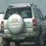 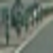 **Car not-Car**

Extracting the features to train the LinearSVM is done in the following steps:

1. Import all images and divide into "car" and "not-car" images. (CarND-Vehicle-Detection.py, Method "get_training_data")
2. Call the "extract_features" method (implemented in features.py)

This method executes each step of extracting the features:

* 1. Color conversion of the picture
  2. extract HOG Features
  3. Spatial Binning of Colors
  4. Color Histogram
  5. Concatenate all single steps to a combined feature vector

For the HOG feature extraction I used the following parameters:

|  |  |
| --- | --- |
| orient | 11 |
| pixels_per_cell | 16 |
| cells_per_block | 2 |
| channels | ALL |

After testing with different parameters, these have turned out to be the best option for me.

Here is a sample image of an image with extracted HOG features.

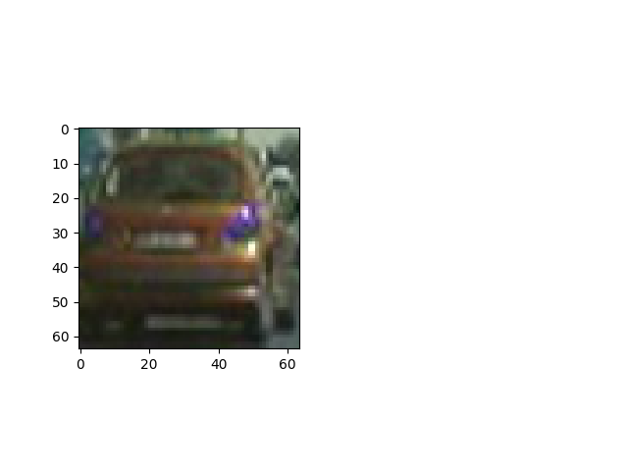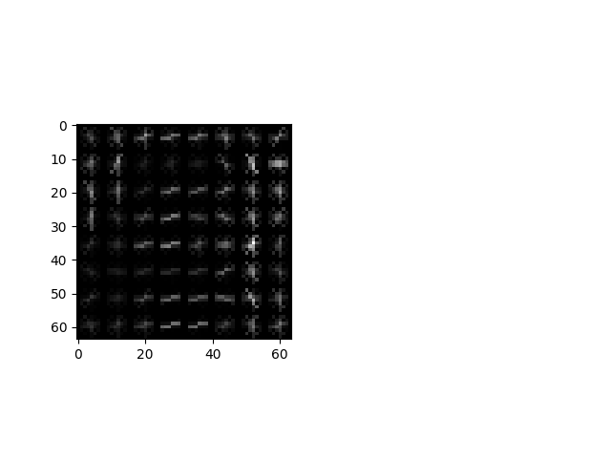

**2. Training the LinearSVM Classifier**

In the file "CarND-Vehicle-Detection.py" in the "main()" method the file "model.pickle" is loaded with the classifier and scaler. If the file does not exist, a LinearSVM Classifier is trained.

To do this, first load the images ("car", "not-car") and extract the features.

Standardize the features by StandardScaler.

Splits of the training (80%) and test data (20%) via "train_test_split" and train the LinearSVM.

**3. Window Search**

The function "slide_window()" has been implemented in the file "search.py". Here is a sample picture of the search over the whole picture.

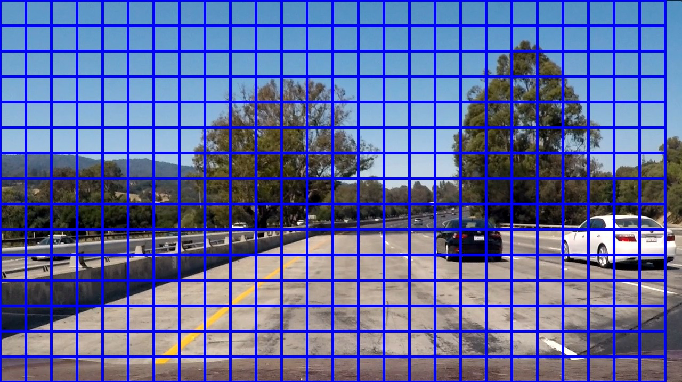

For the actual implementation in the pipeline a "find_cars()" method was implemented. The implementation can be found both as a test function in the "features.py" file and in the "VehicleDetector.py" file for the video.

Here is an example image of the "Hog Sub-sampling Window Search":

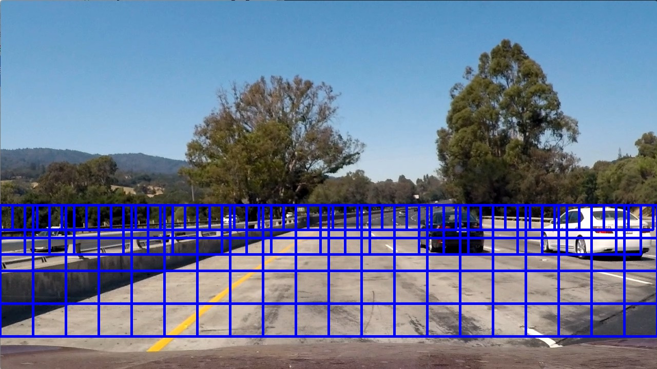

**3. Pipeline**

I've used the following features for the pipeline:

* Color space (YUV)
* Spatially binned color (size=(64, 64))
* Histograms of color (nbins=32)
* HOG features („ALL“ Channels“)
* Different Scales and ROIs

Here are 2 example images (without false/positive removal):

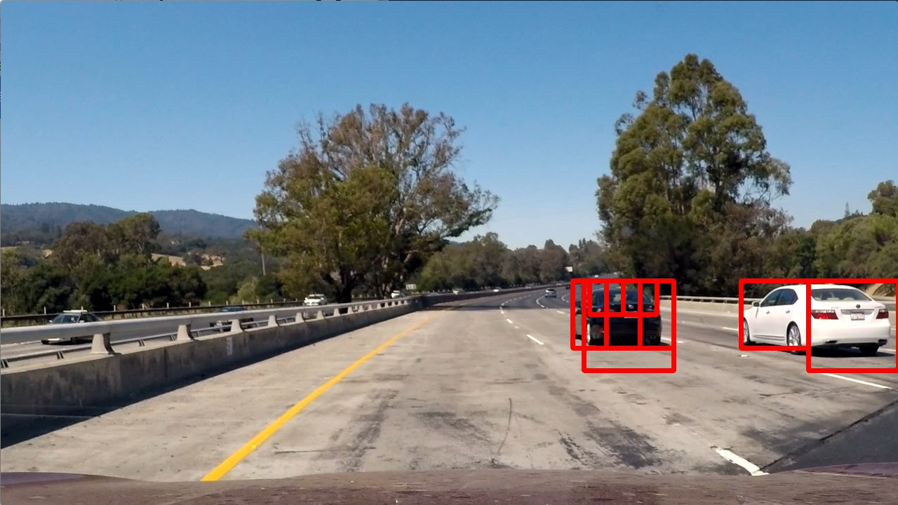 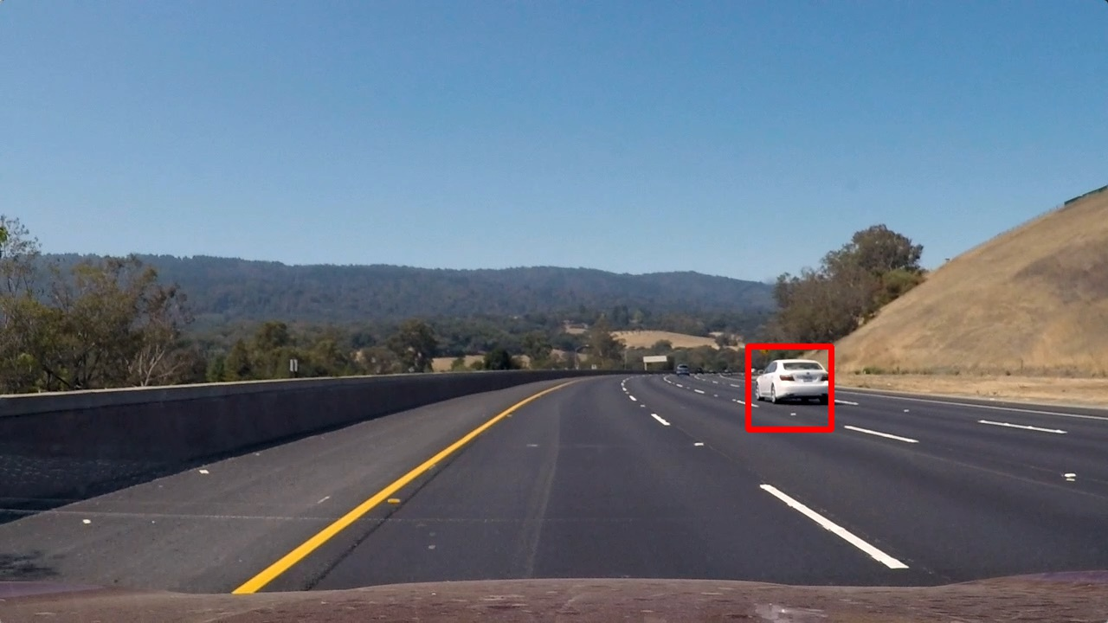

A full video demonstrating the function of the pipeline can be found in the "output_videos" folder.

**4. False/Positive Filter**

To remove the false/positives, I have created a heatmap of all positive detections.

Here are some examples of the heatmap:

 

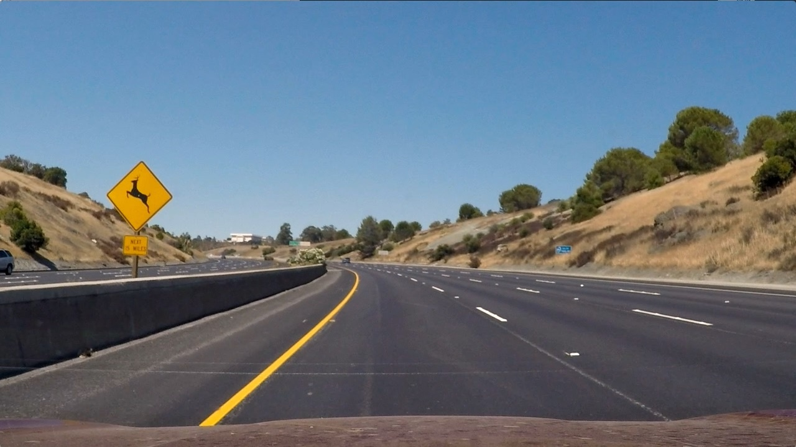 

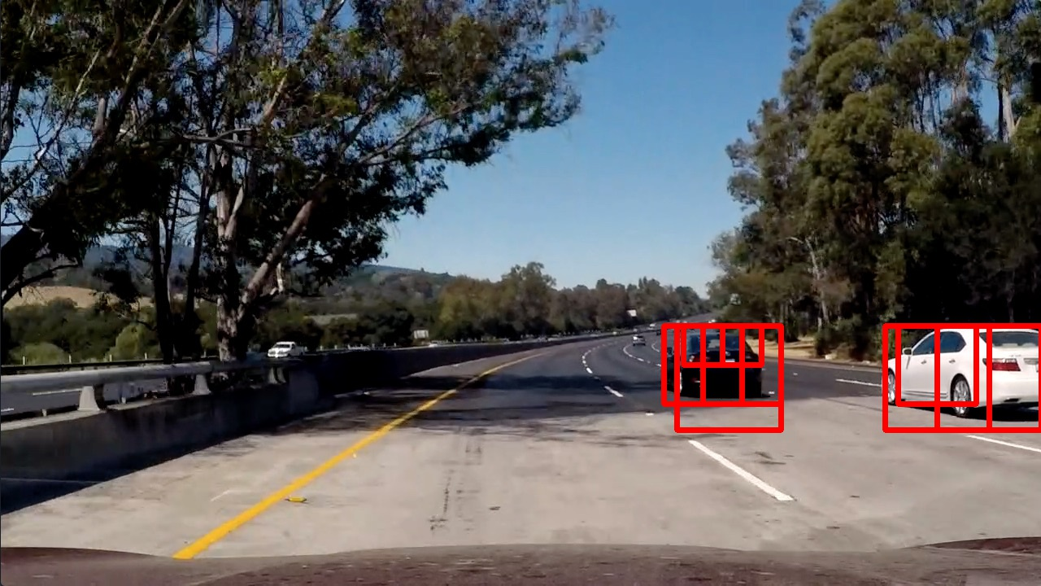 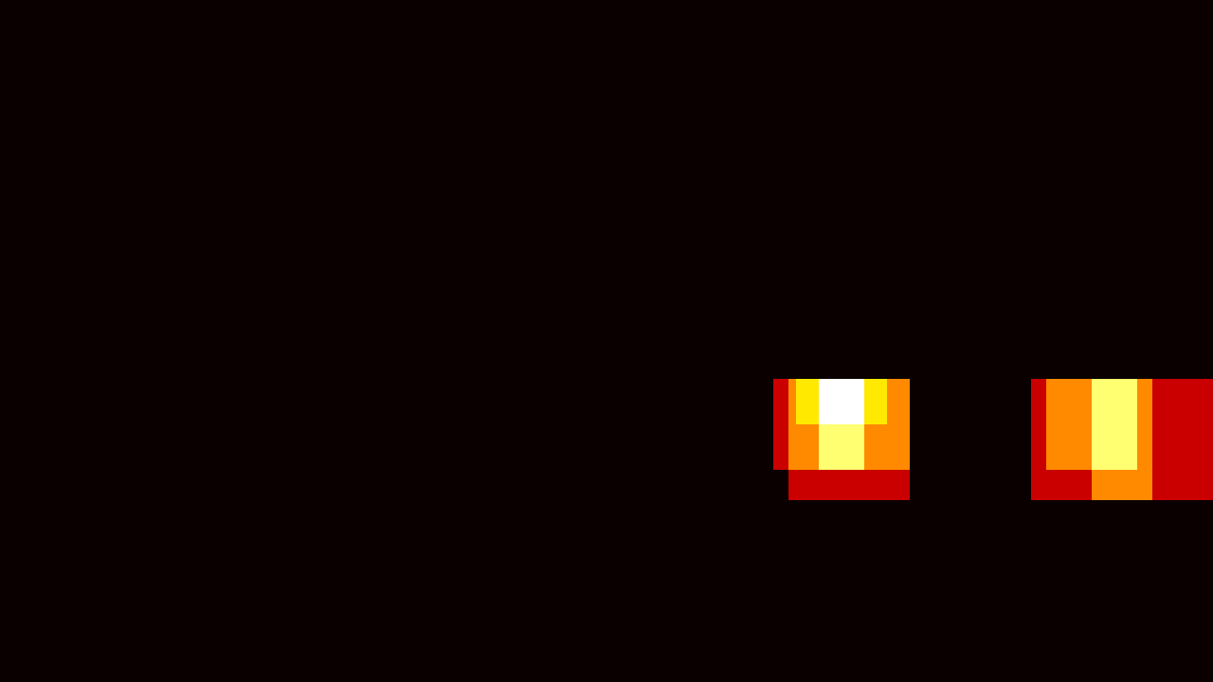

A threshold value is used to determine the vehicle positions. I then used „scipy.ndimage.measurements.label()“ to identify individual blobs in the heatmap. I then assumed each blob corresponded to a vehicle. I constructed bounding boxes to cover the area of each blob detected.

Here are some sample pictures:

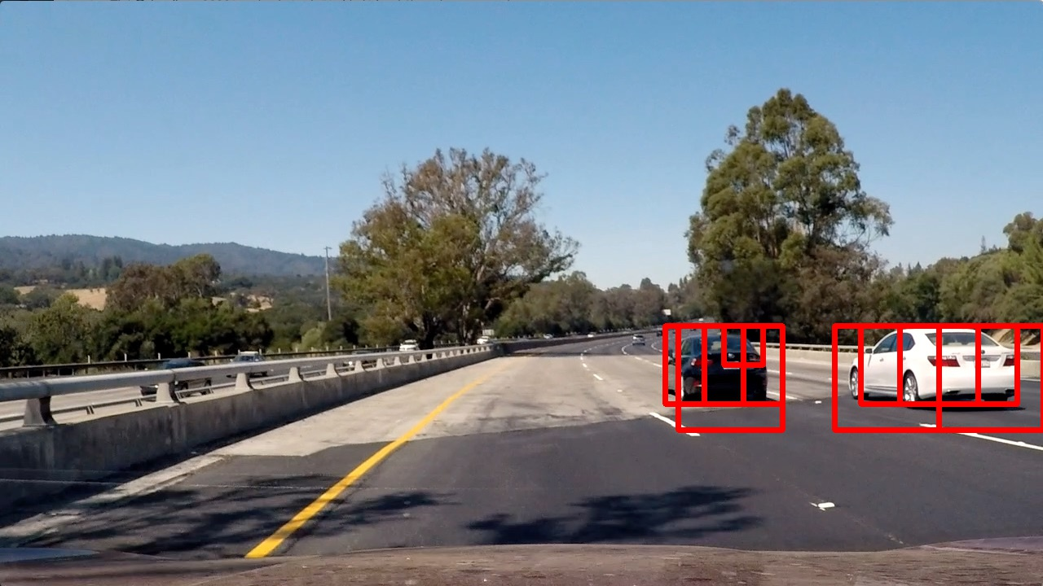  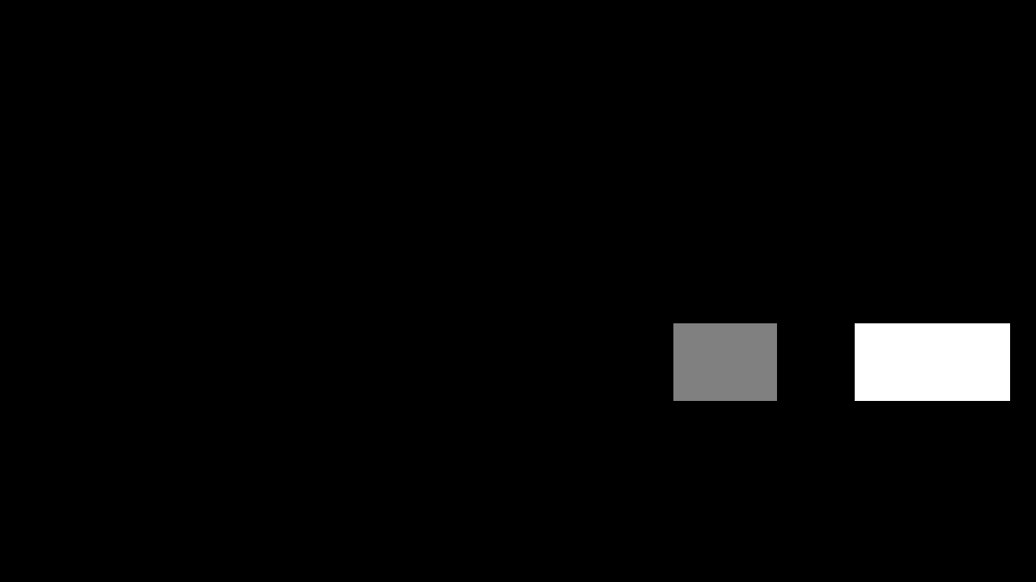

  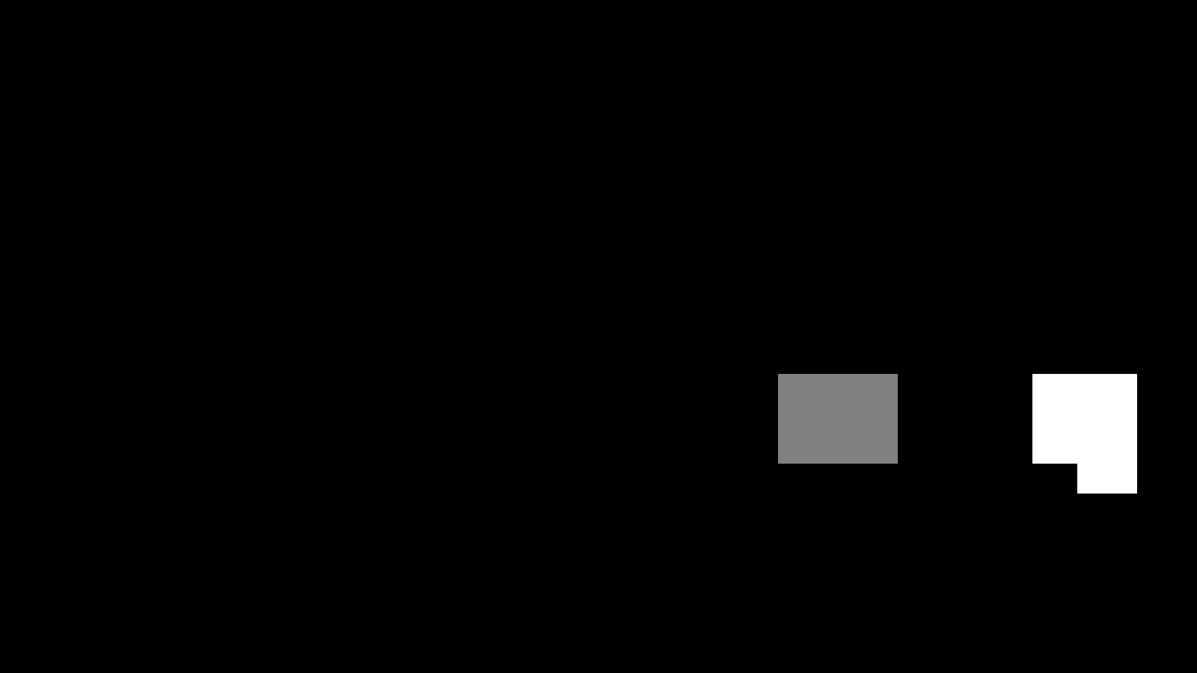

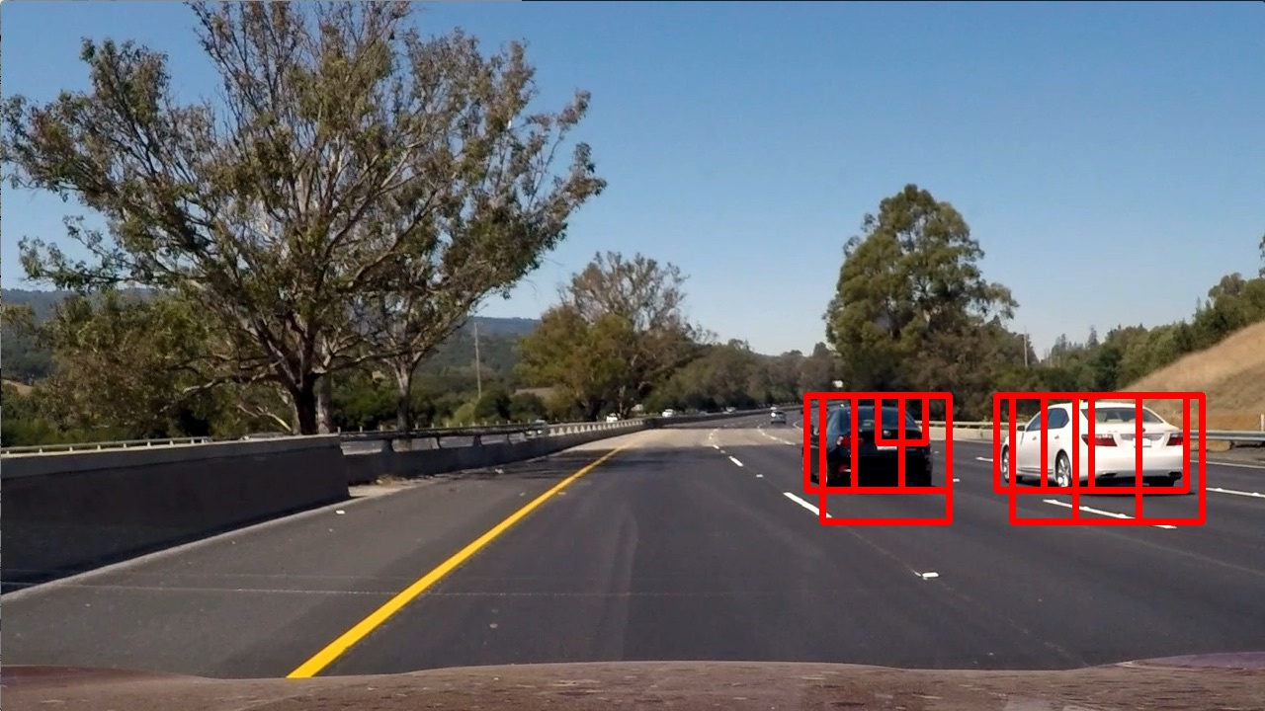 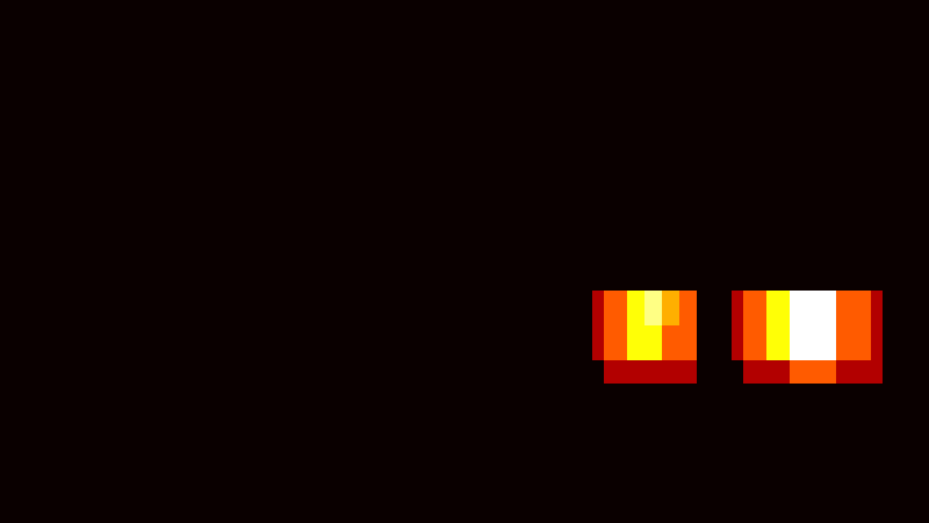 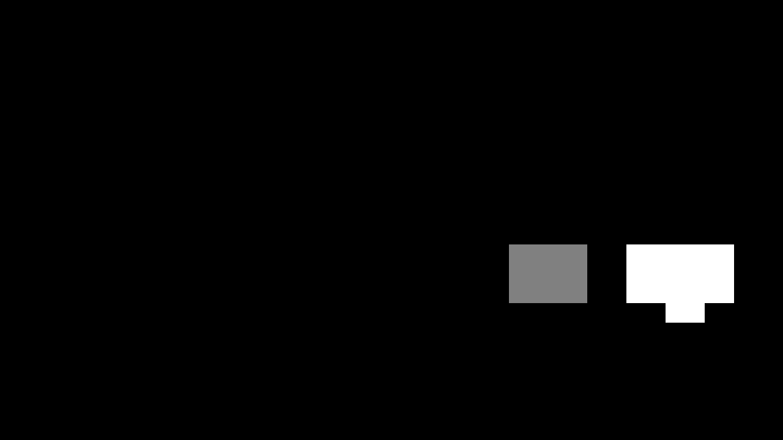

Here's an example after the pipeline has been completely run: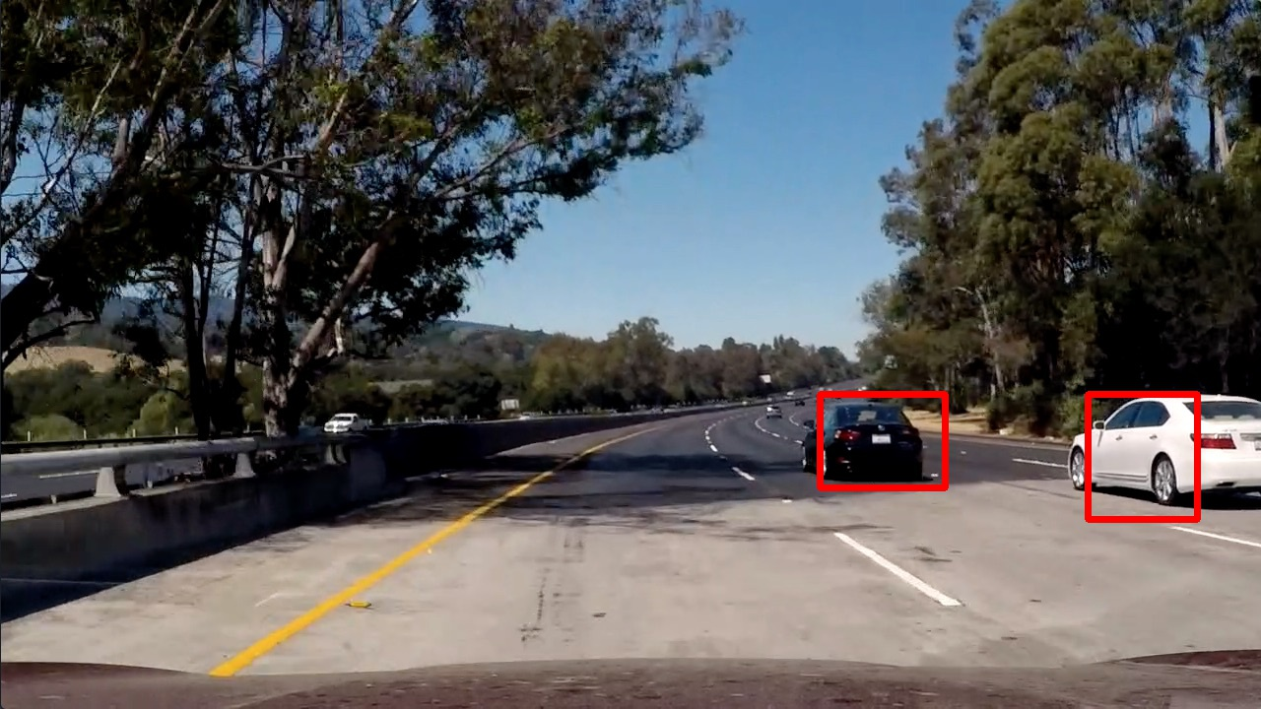

**Discussion**

The biggest difficulties I had with the False / Positive detection. In particular, on the opposite lane on the left side detection has struck more often. To fix the problem, I set the "xstart" for the "find_cars ()" to 400px in the "VehicleDetector". In a productive implementation, the ROI should be determined more dynamically.

Another point is the performance. Currently, the pipeline is too slow to process images in real time. An improvement could be a method such as "YOLO" can be reached (https://pjreddie.com/darknet/yolo/).